***QUIZ 1***

**1.0: Arduino - Blinking the LEDs (Coding and Hardware connection)**

This project shows the simplest thing you can do with an Arduino to see physical output: it blinks the on-board LED.

**Hardware Required**

Arduino UNO

LED

220 ohm resistor

**Schematic**

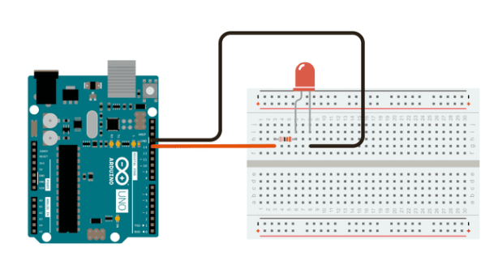

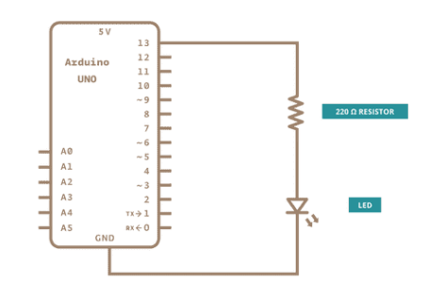

**Code**

#include <stdio.h>

const int ledPin = 13; // declare integer for ledPin to output port no 13

void setup() {

// initialize digital pin LED_BUILTIN as an output.

pinMode(ledPin, OUTPUT);

}

// the loop function runs over and over again forever

void loop() {

digitalWrite(ledPin, HIGH); // turn the LED on (HIGH is the voltage level)

delay(1000); // wait for a second

digitalWrite(ledPin, LOW); // turn the LED off by making the voltage LOW

delay(1000); // wait for a second

}